Version1 August 2022
Code of Conduct

Table of Contents
Help for non-English speakers 2
Purpose 2
Expectations 2
Use respectful language 2
Be supportive 3
Foster a welcoming and inclusive environment 3
Celebrate diversity 3
Working with children and young people 4
Acceptable behaviours 4
Unacceptable behaviours 4
Breaches to the Code of Conduct 5
Approval and review 6

Help for non-English speakers
If you need help to understand this policy, please contact your local Rotary club.

Purpose
Code of Conduct sets out the expected behaviour of everybody participating in an activity of Rotary International district 9815 (the district) and all Rotary and Rotaract clubs within the district (our clubs).

All Rotary and Rotaract members, volunteers, contractors, service providers and any other person involved in Rotary activities must follow the Code of Conduct. The Code of Contact is also a key element of our risk management for child safety as it not only sets out expected behaviours, but it also sets an expectation of behaviour of adults with children and young people.

This code of conduct reflects our core values of fellowship, integrity, diversity, service, and leadership, and explains the responsibility that comes with being a Rotary and Rotaract member.

Like our core values, we expect Rotary and Rotaract members to exemplify this code of conduct as they interact with one another, Rotary program participants, Alumni, project partners, children and young people and members of the community. Specifically, the code of conduct applies at all club, district, zone, and Rotary International meetings, trainings, events, and anywhere else a member represents Rotary and, on My Rotary, social media and online, and any other environments.

Expectations
All club members and other participants including Rotary program participants, Alumni, project partners, volunteers and representatives of Rotary are expected to comply with this code of conduct, be considerate and contribute to a collaborative, positive, and healthy environment in which all are respected and valued.

Use respectful language
- When you first meet someone, introduce yourself and explain how you would like to be addressed, ideally including your preferred pronouns (he/him/his, she/her/hers, they/them/theirs, etc.). Call others by their preferred name, rather than using a nickname that is easier to pronounce.
- When addressing larger groups, utilise gender neutral words to avoid gender assumption.
- Use active listening to deepen your understanding of others.
- Be conscious of language use and adapt as necessary, depending on region or cultural background of a person. Some wording is acceptable in some cultures but unacceptable in others.
- Avoid slang or idioms that do not translate across cultures or be deliberate in explaining them to share our diverse cultures and languages.
- Speak plainly and avoid acronyms and jargon that not everyone may understand.
- If you are curious about someone’s cultural background, faith, sexual orientation, gender, or another characteristic, ask if they are open to sharing more about themselves. Refrain from asking if the topic is not relevant to your conversation.
- Foster an atmosphere of intergenerational dialogue and avoid describing anyone by their age.

Be supportive
- Be an ally and advocate for others and be ready to intervene when you see a need.
- If you see or hear something inappropriate, address the behaviour in a way to offer support to those affected.
- As a member of Rotary and Rotaract, uphold the Code of Conduct, build this culture within your club experience, and address any issues as they arise.

Foster a welcoming and inclusive environment
- Ensure every member and participant can fully engage in any meeting, event, or activity that you organise in person or online by offering (as needed) an accessible venue, simultaneous interpretation, closed captioning and/or transcripts and other resources. Ensure you ask if people need anything to be able to access the meeting, event, or activity when they register/join.
- Review any club or program traditions and stop or change activities that may be offensive or alienating to a specific group.
- Create a welcoming environment and include all in conversations, projects, and events.
- As much as possible, pay attention to nonverbal communication such as eye contact, facial expressions, tone of voice, personal space, gestures, and posture, and how it impacts your ability to engage with and relate to others.
- Know the important dates of various religions and schedule events and activities in a way that is inclusive and considerate of people who observe them.
- Be aware of people’s dietary and health restrictions.
- Open opportunities for everyone to hold leadership roles in your club and district or engage with your community partners.

Celebrate diversity
- Increase your club’s awareness, understanding, and acceptance of people with disabilities.
- Celebrate a variety of cultural events and religious observances, rather than continually conducting service projects or hosting events associated with a single culture or religion.
- Acknowledge and celebrate significant dates relevant to diversity.
- Avoid stereotyping and mocking any specific group.
- Acknowledge and celebrate different genders.

Working with children and young people

Acceptable behaviours
As Rotary and Rotaract members, volunteers, service providers, and any other member of our community involved in child-connected work, we are responsible for supporting and promoting the safety of children by:
- always upholding our commitment to child safety and adhering to our Child Safety and Wellbeing Policy
- treating children and young people, and families in our community with respect in Rotary environments and outside our Rotary environments as part of normal social and community activities
- listening and responding to the views and concerns of children and young people, particularly if they disclose that they or another child or young person has been abused or are worried about their safety or the safety of another child or young person.
- promoting the cultural safety, participation and empowerment of Aboriginal children and young people, children and young people with culturally and/or linguistically diverse backgrounds, children and young people with a disability, international students (i.e. those involved in Rotary Youth Exchange), children and young people who are unable to live at home, and lesbian, gay, bisexual, transgender, gender diverse and nonbinary, intersex, queer and questioning (LQBTIQ+) children and young people.
- ensuring, as far as practicable, that adults are not alone with a child or young person; one-to-one interactions between an adult and a child or young person are to be in an open space or in line of sight of another adult.
- reporting any allegations of child abuse or other child safety concerns to your club’s protection officer and/or the district protection officer.
- understanding and complying with all reporting and disclosure obligations (including mandatory reporting) in line with our child safety responding and reporting policy and procedures.
- if child abuse is suspected, ensuring as quickly as possible that the child or young person are safe and protected from harm.

Unacceptable behaviours
As Rotary and Rotaract members, volunteers, service providers and member of our community involved in child-connected work we must not:
- ignore or disregard any concerns, suspicions or disclosures of child abuse or harm
- develop a relationship with any child or young person participating in our programs that could be seen as favouritism or amount to ‘grooming’ behaviour (for example, by offering gifts).
- display behaviours or engage with children or young people participating in our programs in ways that are not justified by the context.
- ignore an adult’s overly familiar or inappropriate behaviour towards a child or young person participating in our programs.
- discuss intimate topics or use sexualised language, except when needed to deliver appropriate curriculum or professional guidance.
- treat a child or young person participating in our programs unfavourably because of their disability, age, gender identity, race, culture, vulnerability, sexuality, or ethnicity.
- communicate directly with a child or young person participating in our programs through personal or private contact channels (including by social media, email, instant messaging, texting, etc.) except where that communication is reasonable in all the circumstances, related to Rotary activities or where there is a safety concern or other urgent matter.
- photograph or video a child or student in a Rotary environment except where required in an official Rotary capacity or for duty of care purposes.
- consume excessive alcohol or take illicit drugs in a Rotary environment or at Rotary events where children or young people are present.
- have contact with any child or young person participating in our programs outside of program hours except when needed to deliver the program or professional guidance and then only where parental permission has been sought.

Breaches to the Code of Conduct
All Rotary and Rotaract members, volunteers, contractors, and any other member of the community who breach this Code of Conduct may be subject to disciplinary procedures in accordance with the district and/or Rotary International policies and procedures, a relevant professional code, or terms of engagement.

In instances where a reportable allegation has been made, the matter will be managed in accordance with the with the district and/or Rotary International policies and procedures and may be subject to referral to Victoria Police.

Rotary is committed to maintaining an environment that is free of any form of harassment, broadly defined as any conduct, verbal or physical, that denigrates, insults, or offends a person or group based on any characteristic1 (age, ethnicity, race, colour, disability, religion, socioeconomic status, culture, sex, sexual orientations, or gender identity).

If you are notified or suspect a breach of this code of conduct, or you feel you have been harassed, follow these steps:
- If anyone’s safety is in doubt, contact Victoria Police.
- Notify a club officer (club president or secretary), district leader (district governor or district governor elect, or district protection officer), or zone leader (RI director).
- District Governor is obligated to report the incident to Rotary International’s Club and District Support team by contacting cds@rotary.org.
- District Governor must report any allegation of harassment or abuse that involves children or young people must be reported to Rotary International at youthprotection@rotary.org within 72 hours.

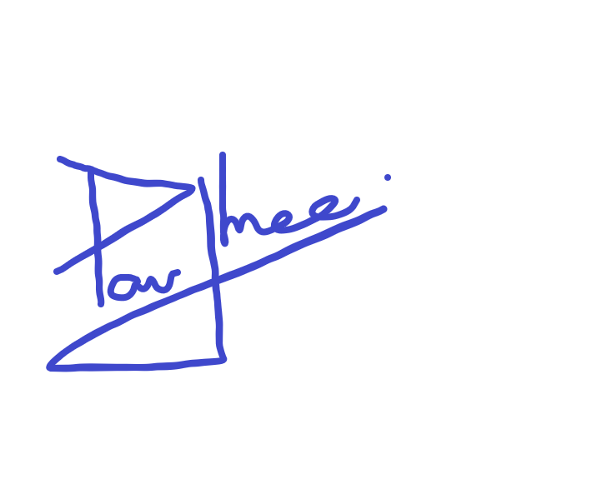 District Governor & D9820 Board Chair

Approval and review
Last reviewed | 15th August 2022
Consultation | For Future Review
Approved by | District 9820 Board – 22nd Sept 2022
Next scheduled review date | 22nd September 2024

